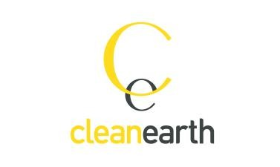
Unit 2a Bess Park Road, Trenant Industrial Estate, Wadebridge, Cornwall, PL27 6HB
www.cleanearthenergy.com

Position Title: Operations & Maintenance Project Manager / Asset Manager
Company: Clean Earth Energy
Salary: £25,000 - £35,000
Location: Wadebridge, Cornwall
Duration: Full-time contract
Closing date: NA

Company background:
CleanEarth design, build, and operate Solar Photovoltaic (PV) and Wind Turbine renewable energy systems throughout the United Kingdom.
Founded in 2010, our industry-leading in-house team of engineers, planners and project managers provide a complete 360-degree service, incorporating every aspect of the project development process and ensuring Clean Earth are always one step ahead.
This unique approach allows Clean Earth to tackle every project head-on, with the in-house resources to provide a truly holistic service.

Job Description:
Clean Earth are looking for a motivated and organised Operations & Maintenance Project Manager to join our expanding team.

Responsibilities will include:
- Reviewing and monitoring all asset managed renewable energy sites, via online portals, ensuring operational sites are managed to the highest health, safety, quality and environmental standards
- Diagnosing and developing solutions to faults and/or system underperformances
- Reviewing site inspection reports and providing feedback on solutions
- Collating data on sites and relevant obligations for scheduling purposes
- Reporting to clients following engineer inspections and or identification of system faults.
- Providing feedback on site performance to make improvements to ongoing operation.
- Liaising with clients, DNOs and external consultants.
- Liaising with O&M team and providing updates on works carried out by engineers.
- Liaising with landowners and clients to provide access to carry out works.

Essential Requirements:
- Minimum 1 years’ experience of working the operation on commercial PV Systems
- Methodical, accurate and process focused approach
- Excellent communication and organisational skills – internally & externally
- Be solution focused and goal oriented
- Proficiency with Excel
- Driving License

Desired Skills:
- CAD experience
- Renewable Energy Industry knowledge and experience
- Degree-qualified in renewable energy, engineering or similar


How to Apply: Please send a C.V. and covering letter outlining why you are suitable for the role to chloe.moss@cleanearthenergy.com

